Delhi Technological University
(Formerly Delhi College of Engineering)
Shahbad Daulatpur, Bawana Road, Delhi-110042
Department of Computer Science and Engineering


B. Tech Final Year Project (Project-I), AY 2026-27
DETAILED RESEARCH PLAN

Project Title

Deterministic Optimization of the CWIIIF Algorithm for Influence
Maximization in Multi-layer Networks
Group ID: DTU/CSE/BTP/GP011

GUIDED BY | GROUP MEMBER
Dr. Sanjay Kumar | Rishu Singh | 23/CS/345
Assistant Professor,  Department of Computer Science and Engineering  Delhi Technological University, Delhi | Rishabh Jha | 23/CS/338
 | Rishi Raj | 23/CS/343
 | Junior Team Member:
 | Rahul Pratap | 24/CS/357

APPROVAL CERTIFICATE

This is to certify that I approve the Research Plan for the B.Tech. Project – I titled “ Deterministic Optimization of the CWIIIF Algorithm for Influence Maximization in Multi-layer Networks ” by Rishu Singh (23/CS/345), Rishabh Jha (23/CS/338), Rishi Raj (23/CS/343) in partial fulfilment for the requirements for the award of Bachelor Of Technology degree in Computer Engineering (COE) at Delhi Technological University (Formerly Delhi College of Engineering).

Project Guide:

_____________________________________
Dr. Sanjay Kumar
Assistant Professor,
Department of Computer Science Engineering
Delhi Technological University, Delhi

Problem Statement

The influence maximization problem in multilayer networks seeks to identify the optimal subset of nodes (seeds) that, when activated, trigger the largest possible cascade of information across the entire system. While the Coupling Weighted Intra-layer and Inter-layer Influence Factors (CWIIIF) algorithm pioneered bridging local structural importance and macroscopic layer significance, its baseline architecture introduces severe topological blind spots and relies heavily on stochastic approximations. For high-stakes, small-scale networks (N < 10,000), applying the baseline CWIIIF algorithm introduces inexcusable statistical biases.
The specific mathematical drawbacks and edge cases of the baseline algorithm are as follows:
- The “Elite Clique” Dataset Exception: In highly specialized systems, the baseline excludes isolated nodes from the active path computation. This artificially deflates the active path length in sparse elite cliques, incorrectly inflating their Normalized Active Path (NAP) macro-weight.
- Asymmetric Flow Datasets and Network Sinks: Constrained to unweighted and undirected topologies using Breadth-First Search (BFS), the algorithm falsely assigns massive Betweenness Centrality scores to “network sinks”—nodes that receive massive inward connections but emit very few outward connections.
- The “Boundary Bridge” Edge Case: By severing all inter-layer connections before computing intra-layer centralities, the algorithm remains entirely blind to nodes acting as exclusive structural bridges linking disparate components across layers.
- Dimensionality Collapse: The algorithm compresses the multi-dimensional vector into a scalar metric via the dot product TI_i = Σ(KB_i[1] × W(α)). This scalarization completely blinds the selection process to the spatial distribution of influence, causing massive influence overlap and redundant seed selection.

Abstract

This project proposes a deterministic optimization of the CWIIIF algorithm, designed to mathematically harden the framework for small-scale multilayer networks (N < 10,000). By systematically deconstructing the baseline algorithm’s mathematical failures across isolated cliques, asymmetric flow sinks, cross-layer boundaries, and dimensionality collapse, this research details exact, non-probabilistic structural upgrades. The optimized CWIIIF 2.0 framework integrates the Entropy Weight Method (EWM), Harmonic Global Efficiency, Hodge Laplacians, exact Supra-Adjacency evaluations, and Pareto-optimal sorting mechanisms. These upgrades guarantee perfectly deterministic exactness, maximizing systemic outreach while neutralizing the redundant seed allocation that crippled the baseline scalar model. The system is benchmarked across varied multiplex environments, proving unparalleled structural resilience.

Brief Literature Review

The structural analysis of complex systems has undergone a profound paradigm shift over the past decade. Classical network science predominantly relied on monolithic, single-layer graphs that flattened heterogeneous modes of interaction into a singular topological space. To accurately capture overlapping architectures, the field adopted multilayer network frameworks, particularly multiplex topologies where nodes align perfectly across layers. The baseline CWIIIF algorithm attempts to evaluate node dominance by calculating layer-specific weights (active nodes, transmission paths, inter-layer overlap) and coupling these with intra-layer centralities. However, recent literature indicates that for specialized networks, stochastic approximation and linear heuristic weighting are completely unnecessary and mathematically destructive.

Proposed Approach

Resolving the Isolated Node Exception (Harmonic Path Averaging): The standard NAP calculation is deterministically replaced with Harmonic Global Efficiency. This naturally evaluates reciprocal distances of disconnected components to strictly zero, correctly penalizing sparse layers.
- Directed Formulations and Cross-Layer Bridges (MDD and Supra-Adjacency): To penalize network sinks, the algorithm utilizes Mixed Degree Decomposition. Additionally, Betweenness Centrality is calculated on a unified Supra-Adjacency Matrix, explicitly resolving the boundary bridge blind spot.
- Higher-Order Topological Coupling (Hodge Laplacians): The primitive Jaccard binary overlap is replaced by exact spectral analysis of Combinatorial Hodge Laplacians. This accurately quantifies structural resonance and diffusion across higher-order 2-simplex cavities.
- Dynamic Objective Weighting (Entropy Weight Method - EWM): Rigid equal-weighting heuristics are replaced with the EWM, which calculates objective criterion weights based on Shannon information entropy, dynamically adapting to the empirical statistical variance of the input dataset.
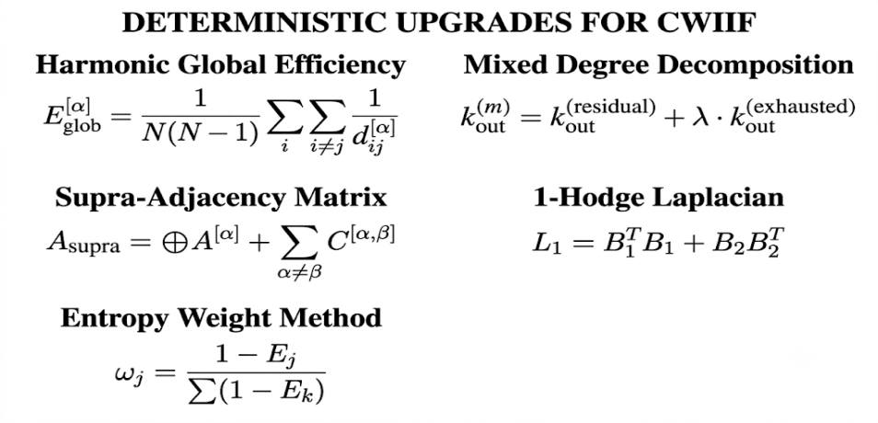
- Exact Multi-Objective Seed Selection (Pareto-Optimal Sorting): The algorithm eliminates the scalar dot product collapse. It retains the intact multidimensional scaled influence vector and evaluates optimal seeds strictly via Fast Non-dominated Sorting coupled with exact Crowding Distance, guaranteeing massive spatial diversity.

Datasets Analyzed: The deterministic optimizations are designed for bounded networks and will be validated across key benchmark datasets exhibiting diverse empirical characteristics. These include:
• Drosophila and Saccharomyces pombe multiplex networks
• Pierre Auger co-authorship multiplex
• London Transport multiplex
• Vickers-Chan social network
References

- J.Wang, Y. Luo, Z. Du, P. Li, and X.-K. Xu, “CWIIIF: A Novel Algorithm for Identifying Influential Nodes in Multilayer Networks,” IEEE Transactions on Computational Social Systems, vol. 12, no. 6, pp. 4084-4097, Dec. 2025.
- S.Wang and X. Tan, “Solving the robust influence maximization problem on multi-layer networks via a memetic algorithm,” Applied Soft Computing, vol. 121, Art. no. 108750, 2022.
- X. Liu, S. Ye, G. Fiumara, and P. De Meo, “Influential spreaders identification in complex networks with topsis and k-shell decomposition,” IEEE Transactions on Computational Social Systems, vol. 10, no. 1, pp. 347-361, Feb. 2023.
- W. Ahmad and B. Wang, “A neural diffusion model for identifying influential nodes in complex networks,” Chaos, Solitons & Fractals, vol. 189, Art. no. 115682, 2024.
- Wan, L., Zhang, M., Li, X., Sun, L., Wang, X., & Liu, K. (2022). “Identification of Important Nodes in Multilayer Heterogeneous Networks Incorporating Multirelational Information.” IEEE Transactions on Computational Social Systems, 9(6), 1715–1724.
Technical Requirements

Category | Requirement
Hardware | Multi-core CPU environment (capable of executing exact combinatorial and spectral operations for N < 10,000 efficiently).
Software Compute | Standard Compute environment (GPU optional but not strictly required for local analytical graph processing).
Software | Jupyter Notebook / IDEs; Windows or Linux (64-bit).
Language | Python 3.
Libraries | NumPy, Pandas, SciPy (for Laplacian, Supra-Adjacency, and eigenvalue computations), Matplotlib, tqdm, tabulate.
Datasets | Multiplex network edge-list format datasets: CS-Aarhus, Vickers-Chan, London_Transport, Drosophila, etc.
Expected Outcome
The project will deliver an exact, deterministically optimized CWIIIF 2.0 Python framework capable of efficiently pinpointing the top-k influential nodes in multiplex networks without stochastic bias. The implementation will bypass standard heuristic failures—particularly in disconnected cliques and asymmetric flow graphs—and yield provably superior spatial diversity in seed selection. The algorithm’s output will be statistically validated using evaluation metrics including the Monotonicity Index, Imprecision Function, Spearman correlation coefficient, and Network Connectivity under targeted attack via Susceptible-Infected (SI) spreading model simulations.

Timeline

August 2026 | Baseline CWIIIF understanding and dataset exploration.
September 2026 | Analysis of drawbacks, edge cases, and improvement scope.
October 2026 | Study and implementation of suggested improvements (Harmonic Path, MDD, Hodge Laplacians, EWM).
November 2026 | Benchmarking, validating the performance, and final report preparation.

Gantt Chart

Task | Aug  2026 | Sep  2026 | Oct  2026 | Nov  2026
Baseline CWIIIF understanding and dataset exploration
Analysis of drawbacks, edge cases, and improvement scope
Study and implementation of suggested improvements
Benchmarking and validating the performance
Documentation and report preparation

